Smart Insider Threat Detection and Employee Risk
Profiling Framework

Swarnasmita Roy
Department of Mechanical Engineering
Amrita School of Engineering
Bengaluru, India
bl.en.u4rae23044@bl.students.amrita.edu
Prakash Marimurthu
Department of Mechanical Engineering
Amrita School of Enginering
Bengaluru, India
k_prakash@blr.amrita.edu

Abstract— The threat posed by insiders is a significant risk to the security system since malicious or careless actions may be carried out by authorized users whose actions seem legal. To analyze insider threats effectively, this paper suggests the use of a hybrid machine learning system, which is a blend of unsupervised anomaly detectors and supervised threat classifiers. The Computer Emergency Response Team (CERT) insider threat dataset is analyzed to extract the behavioral, activity-based, and psychometric features which are optimized by domain-driven feature engineering. Isolation Forest is applied to identify abnormal user behavior with 98% accuracy, 0.88% precision, 0.70% recall and F1-score of 0.78% on pseudo ground truth ranking. The K-Means clustering is further implemented to come up with behavioral risk profile, which aids supervised learning. Lastly, a Random Forest classifier, which conditions users into four threat categories including Benign, Negligent/Overworked, Opportunistic/Suspicious, and Malicious Insider, has a classification accuracy of 94.9% with a precision, recall, and F1-score of over 94%. The findings affirm the capability of the framework to detect undetected insider threats and provide valid and interpretable risk forecasts to active security surveillance.
Keywords— insider threat, cybersecurity, Isolation Forest, K-Means, Random Forest

Introduction
The contemporary organizations create enormous amounts of behavioral and operational data due to everyday digital experiences, such as accessing a system, using a device, and engaging in the communication process [1], [2]. Such data when properly examined can serve to give useful information on user behavior and organizational security posture. The recent developments of the machine learning field have facilitated the transition of security systems out of an environment of fixed rules and into dynamic frameworks that aptly learn behavioral patterns and discern minor outliers. Specifically, the combination of behavioral analytics and psychological profiling has demonstrated potential in increasing the accuracy and usefulness of insider threat monitoring. Data-driven solutions can be used to aid in proactive security decision-making and risk-conscious access control by using a combination of anomaly detection, behavioral segmentation, and supervised classification. This paper examines this type of multi-stage analytical framework to gain a clearer insight into the behavior of users and enhance the ability to monitor insider threats.

Literature Review
Machine learning, deep learning, behavioral analytics, and psychological modeling have been the most common procedures in insider threat detection, but detecting malicious insiders is not an easy task since authorized access can be used, deviations are not pronounced, and labeled data is limited. Sarhan et al. have used Deep Feature Synthesis (DFS) to construct a large space of behavioral features and presented high classification accuracy on Support Vector Machine (SVM) and Principal Component Analysis (PCA), but noted the cost of computation and reliance on synthetic CERT datasets [3]. Charan et al. suggested use of Long Short Term Memory (LSTM) to identify Advanced Persistent Threats (APTs) in real-time corporate and banking networks using large-scale event logs of a Security Information and Event Management (SIEM) to handle stealthy malware and adaptive data exfiltration methods [4].
Nasir et al. came up with a deep learning-based behavioral framework that synthesized user roles and event logs, which performed better than various baseline models, but the framework highly relied on sequential data and could not be generalized [5]. The study presented by Haq et al. examined the insider threat detection in cloud and IoT systems based on hybrid deep learning models and found that traditional machine learning models like Random Forest tend to achieve better results than deep learning methods, especially in false alarm reduction [6]. Abhinav et al. introduced a cloud-based technology that integrates signature-based and anomaly-based machine learning to enhance detection and minimize the false positive of cyber intrusions on the network level [7].
Dosh et al. carried out a comparative study with classical methods of machine learning on the CERT dataset and proved that they achieved reasonable accuracy, but it did not include time-related dynamics and psychological influences [8]. A sentiment analysis technique by Mittal et al. is an NLP-based method, established around email and web traffic, which was, however, restricted to text-heavy contexts [9]. Kim et al. studied the topic of insider threats in IoT systems and found that the data of network and application layers is more efficient as compared to the data of perceptual types [10]. Eberle et al. used graph-based anomaly detection to identify structural deviations in the insider behavior, but scalability in enterprise level was still a problem [11].
Although there is a significant progress, the current literature tends to consider anomaly detection, clustering, and classification as independent activities and does not pay much attention to integrating psychometric indicators and behavioral analytics. Besides, poor explainability, large false-positive rates and inadequate risk stratification makes them difficult to implement practically. These constraints indicate that there is a necessity to have an integrated, interpretable model that integrates behavioral grouping, psychological features location, calibrated anomaly detection and supervised category of threats to enhance detection precision and operational value.

Problem Statement
Although the insider threat detection research has been considerably developed, certain challenges still exist and pose serious constraints to the feasibility of the currently used approaches. It was a gap of knowledge about the causes of risky behavior of some users as in the past studies, it was impossible to integrate psychological traits, risk factors and patterns of user behavior into a distinctions framework. Moreover, there are limited works that provide multi-level risk stratification that corresponds to the organizational needs, and unbalanced datasets and insufficient feature engineering reduces the accuracy of the possible detection of minor insider behavior. To address these gaps, our study proposes an in-depth system of insider threat detection based on behavioral grouping with K-means, supervised threat identification with Random Forest, and tuned anomaly identification with Isolation Forest. It is augmented with behavioral properties which are psychometric and designed. Such a unified approach is not only more effective at classification, precision, and recall but also provides interpretable risk category of Low, Medium, High and Critical, and overcomes the shortcomings of previous research but provides more practical and data-driven solution that can be applied to modern organizations.

Proposed Methodology
A formalized approach is embraced to identify and categorize insider threat systematically and convert raw data about an organization into practical information. An overview of the entire workflow, including data collection and preprocessing, behavioral analysis and threat classification is presented in Fig. 1:
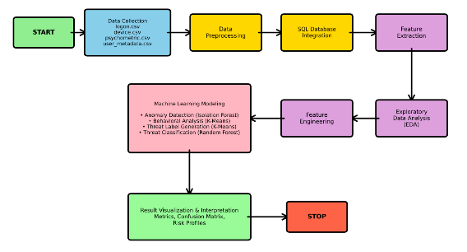
Fig. 1. Methodology Flowchart Implemented for Insider Threat Analysis

Data Collection and Preprocessing
In order to capture user activities, device interactions, psychometric characteristics, and organizational context, the study makes use of a variety of diverse data sources. For analysis, the following datasets are gathered:
- Logon Dataset: Includes authentication records that show the daily trends in access.
Fields: ['id', 'date', 'user', 'pc', 'activity']

- Device Dataset: Contain records of communications with endpoint devices, such as file-tree navigation and events related to operations.
Fields: ['id', 'date', 'user', 'pc', 'file tree', 'activity']

- Psychometric Dataset: Incorporates each employee's Big Five personality trait scores, allowing for behavioral and psychological profiling.
Fields: ['employee name', 'id', 'O', 'C', 'E', 'A', 'N']
(Conscientiousness, neuroticism, extraversion, agreeableness, and openness)

- User Metadata Dataset: Provides every employee access to organizational data and a hierarchical structure.
Fields: ['employee name', 'user_id', 'email', 'role', 'business unit', 'functional unit', 'department', 'team', 'supervisor']
The combination of such datasets allows generating a complete behavioral profile of each user that contains not only human-oriented features (personality characteristics, role, unit of work) but also technical activity tendencies (logon, interaction with devices). This multi-source collection forms the foundation of the core of identifying and simulating insider threats from a precise.
Raw data usually has missing values and discrepancies hence preprocessing is done to supply missing values, normalize numerical variables, encode labels of categorical variables and eliminate duplicate records or corrupted records to provide clean model-ready data..
  - Structured Query Language (SQL) Database Integration
Processed datasets are inserted into a SQL database to allow organized querying, relational linking and to associate logs of user activity with psychometric, device and metadata tables.

  - Feature Extraction

The integrated SQL table is extracted to retrieve domain-specific behavioral data, such as the average daily activity, distinctive number of devices, after-hours ratio, logon times, and psychometric indicators of the risk. During this step, raw logs are transformed into high level attributes that effectively present user behavior.
  - Exploratory Data Analysis (EDA)
EDA is done to depict discrepancies of behavior, identify latent patterns, and sense data distributions. Statistical summaries and visual aids contribute to the identification of prevailing trends that determine the tendencies towards insider threats.

Feature Engineering
The raw behavioral and psychometric information is used to generate several engineered characteristics that provide the machine-learning models with an increased discriminative ability. The combination of activity-based indicators and psychological qualities enables the further identification of the nuanced patterns of insider threats.

Machine Learning Modelling
It uses a pipeline of hybrid modelling, which involves:
- Isolation Forest (Anomaly Detection): The Unsupervised model that detects the users with unusual behavioral patterns and produces anomaly scores without labeling.
- Behavioral Clustering (K-Means): Assimilates users within understandable behavior risk groups according to activity and psychometric assimilation.
- Threat Classification (Random Forest): Model trained with Synthetic Minority Oversampling Technique (SMOTE) balanced data to classify users based on four threat levels with a high accuracy and F1-score.

Result Visualization and Interpretation
In order to extract useful insights, the methodology's last step focuses on analyzing and visualizing model outputs.
- SQL-Based Data Integration
The data integration is conducted with the use of SQL, which allowed to unify diverse insider threat data into a coherent and consumer-friendly format that could be analyzed or used in machine learning. The primary linking key and foreign key on all tables is the ‘user_id’ which guaranteed the consistency of mapping of the behavior of a user in logging in, use of the device, access of files and even personality traits to a particular user.
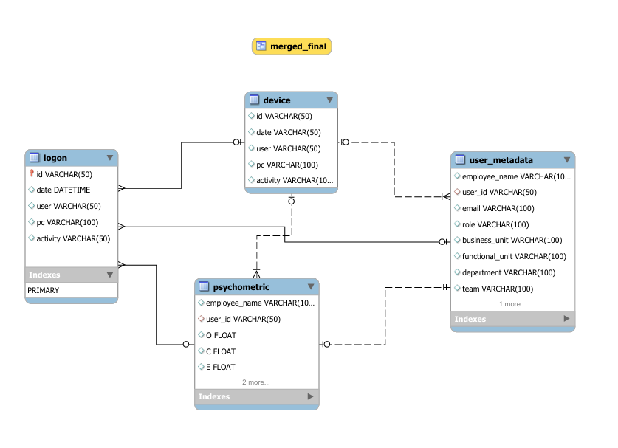
Fig. 2. Entity-Relationship Diagram for Insider Threat Detection Database
Fig. 2 presents the Entity-Relationship Diagram (ERD) which illustrates the manner in which the ‘user_id’ can be used to relate device, psychometric, login, and metadata tables into a single dataset allowing the subsequent extraction of features and subsequent analysis of the data to detect anomalies and classify the threats.
- Construction of Domain-Driven Risk Features
In order to improve model discriminative capacity, raw behavioral logs and psychometric qualities are converted to domain-specific risk indicators. The use of engineered features (Table I) is made by integrating activity-based and psychological measures due to the inability of baseline features to capture subtle interaction between digital behavior and personality traits. Those characteristics enhanced detection of anomalies and classification of threats by having better behavioral representations and a better distinction between normal and high-risk users.
Table I. Set of Engineered Features
Engineered Feature | Formula | Reason for Inclusion
Neuroticism after-hours risk | Neuroticism × average after hours ratio | Captures the emotional instability that is often linked to risky or unusual behavior when it manifests itself in unsupervised or late-hour activity patterns.
Openness activity risk | Openness × average unique activities | Evaluates curiosity-driven system/file exploration; users with high openness tend to do a variety of tasks, which may be a sign of probing or exploratory intent.
Composite risk score | Weighted sum of key behavioral + psychological risk indicators | Combines several high-impact factors to create a single, easily interpreted score that is used for anomaly ranking, creating a unified risk metric.
Risk rank | Rank(composite riskscore) | The top-risk users can be easily identified for additional examination by assigning ordinal risk levels.

MACHINE LEARNING ALGORITHMS FOR INSIDER THREAT ANALYSIS
In this paper, three complementary machine-learning methods have been used to accurately label potential threats, group users into meaningful risk profiles, and reflect anomalous behavior.
  - Isolation Forest for Anomaly Detection
The idea behind the Isolation Forest is that abnormal users have patterns of behavior that are simpler to isolate than those of regular users. In order to identify abnormal insider activities, the algorithm is used in this study on engineered behavioral psychometric features like average unique pcs, average after-hours ratio, openness activity risk, and neuroticism afterhours risk, Composite risk score. The detailed process is as follows:
- Min-Max scaling is first applied in order to normalize behavioral and psychometric features in order to provide equal contribution.
- Isolation Forest constructs various random trees by randomly splitting the users based on random features and thresholds. A user who behaves abnormally (has been active too late) is put in isolation with a shorter path length.
- Mean isolation depths are calculated to give anomaly scores. To minimize false positives, these scores are calibrated using domain based risk measures.
$$Risk Calibrated Score=$$
$0.6*iso-score+0.25*Composite risk score*0.15*neuroticism after-hours risk$ (1)
- A dynamic threshold is used as percentile to determine high-risk users with optimum precision and recall. Users with over the limit are branded as anomalies (they can be insider threats).

Behavioral Clustering by K-Means Algorithm
K-Means clustering is used to cluster users into behavioral archetypes according to the patterns of activity, psychometric characteristics and engineered risk indicators. As opposed to anomaly detection, this step aims at establishing systematic group of behavior that clarifies different degrees of insider risk. The K-Means algorithm works as follows in the context of the current research:
- There is a collection of selected features that capture the technical and psychological behavior, including after-hours activity, diversity of device usage, the volume of activity every day, personality traits, and engineered risk features.
- The algorithm puts users in four groups, each group is formed with the help of Euclidean distance, and centers are constantly updated until a convergence.
- The cluster centroids are records of average behavioral profiles and with the help of them, it is possible to interpret the prevalent behavior patterns in each group.

Supervised Threat Classification with Random Forest Algorithm
The final supervised learning model used, which is the Random Forest, is used to categorize the users into the respective insider-threat groups based on behavioral, psychometric, and engineered risk characteristics. This model learns discriminative patterns according to labeled data, and the threat labels are obtained by K-Means behavioral clustering. The algorithm works in the following steps in the context of the study presented here:
- The classifier relies on the key measures of behavior (after-hours activity, device usage, logon-logoff patterns), risk indicators that are engineered, as well as on the psychometric characteristics selected.
- Given that insider threats are uncommon, SMOTE is used on the training set to even minority classes of threats, which is essential in learning high-risk behavior.
- Several decision trees are trained using random data and features subsets. A tree is a predictor of a threat label calculated individually and based on the learned behavioral rules.
- The classification of threats based on the majority vote among all the trees is then achieved to enhance greater strength and precision.

Results and discussions
Here, the experimental results of the insider-threat detection framework designed, along with the effectiveness of individual machine-learning elements are discussed:

Insights concluded from EDA
Several key insights emerged from the distribution plots generated across logon behavior, device usage, and OCEAN personality traits.
- Login Time Distribution

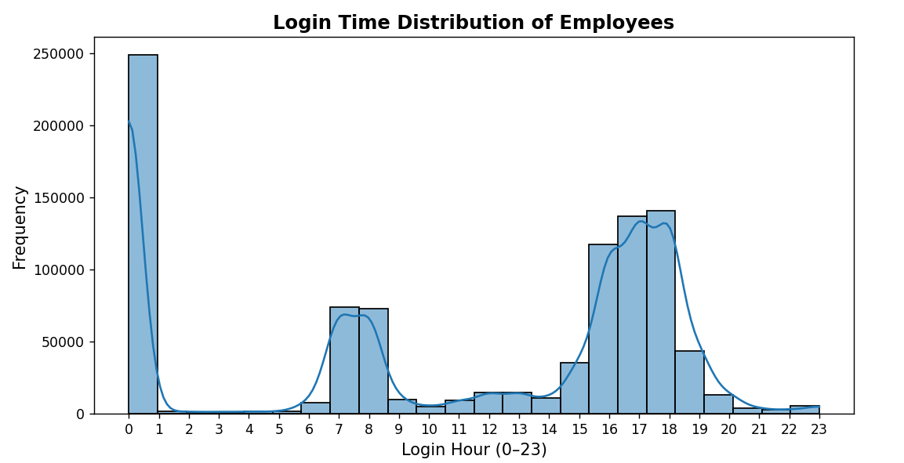
Fig. 3. Login Time Distribution of Employees
The record of the login-hour (Fig. 3) presents a peak at the early morning (7-8 AM), normal working hours (3-6 PM), and a sharp peak at around midnight. Although the daytime activity is normal and a sign of normal pattern of work, the frequency of midnight insider-logins signifies anomalous after-hours activity that is linked to increased risk of insider. The wide distribution of the time of logging in indicates different working hours, which makes the use of abnormality detection to understand the presence of abnormal behavior justified.
- Role Based Activity after Work Hours
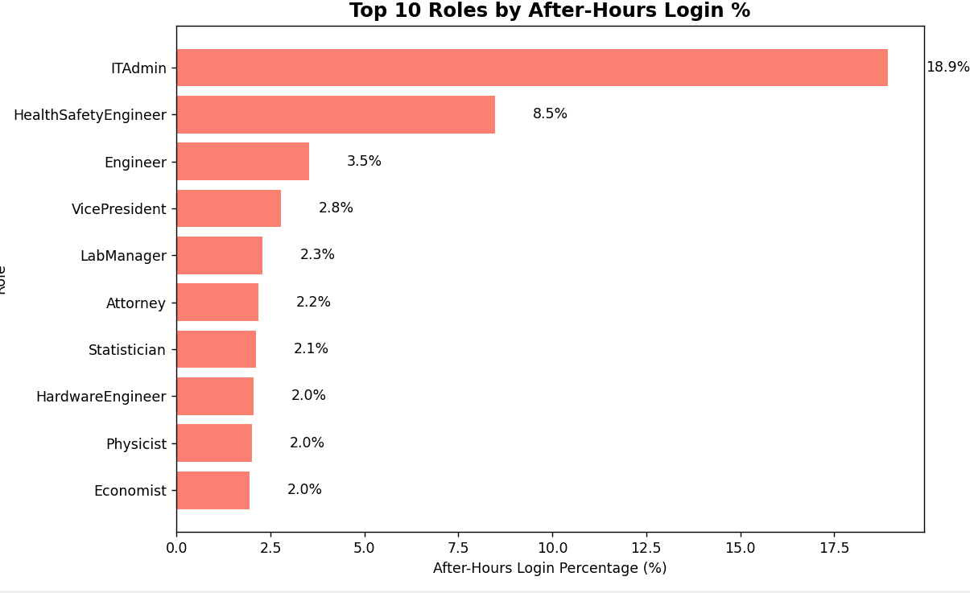
Fig. 4. Role Based Activity
According to the bar chart in Fig. 4, the highest after-hours activity is noted with IT Admins, as it is predicted by the high range of system privileges and system maintenance. The moderate post-hours activity of such technical and managerial positions as Engineers, Vice Presidents, and Lab Managers can also be attributed to the lengthy working hours and to the increased level of access that can expand the insider-risk exposure.
- OCEAN Psychometric Traits distribution
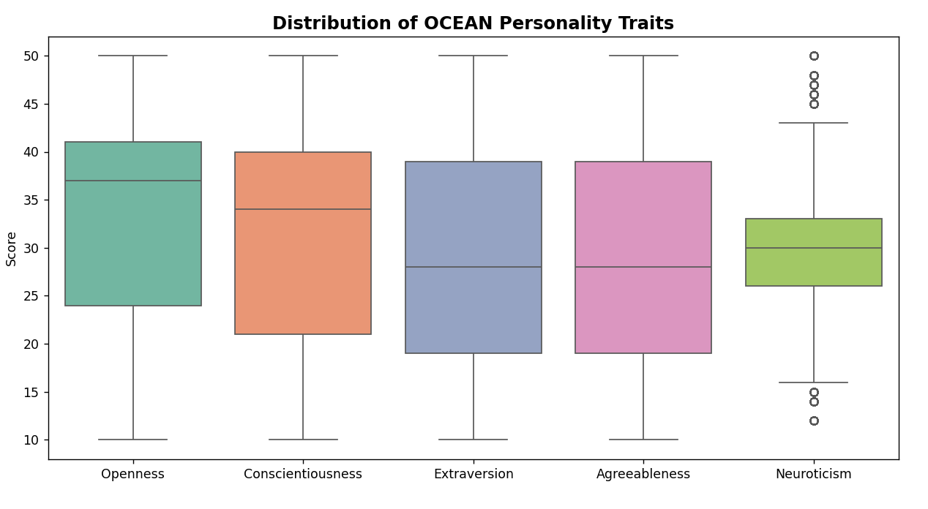
Fig. 5. Distribution of OCEAN Personality Traits
The OCEAN boxplot in Fig. 5 shows how the psychological characteristics of the employees vary. There is a comparatively high median of Openness and Conscientiousness. On the other hand, Neuroticism is more widely distributed with multiple outliers, which means that emotional instability is also different among users to a large extent.
- Distinct PC Usage Distribution
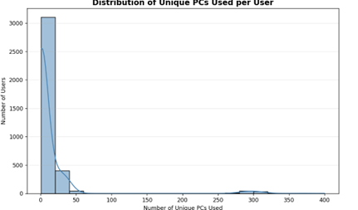
Fig. 6. Distribution of Unique PCs per User
Fig. 6 illustrates a skewed distribution of the unique PCs visited by a user to the right. The majority of the employees have 1-10 devices, which is the reflection of normal organizational behavior, and the small percentage of employees has a very high number of PCs (50+). This is an unusual wide access of a device and can be seen as a sign of a lateral movement or probing that is typical of insider threats.

Analysis of Isolation Forest Results
Isolation Forest, though unsupervised, uses a pseudo ground truth that is based on the top 5% most risky users using the composite risk score to compute the evaluation metrics.
- Confusion Matrix Interpretation and Detection Quality

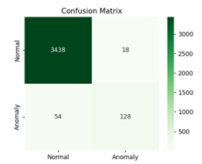
Fig. 7. Confusion Matrix from Isolation Forest
The false-positive rate is very low as in Fig. 7, a false-positive rate of 18 out of 3,438 false-positive users is found to be very low. This model identifies 128 high-risk users correctly and 54 false alarms, which proves to be very reliable, which is a critical factor in insider-threat detection because false alarms are to be avoided at all costs.
- Evaluation of Performance Metrics
The metrics in Table II are the measures of consistency with the behavior ground truth, which implies that the model is capable of detecting serious inconsistencies in user behavior.
Table II. Evaluation Metrics for Isolation Forest
Metric | Score
Accuracy | 0.980
Precision | 0.877
Recall | 0.70
F1-Score | 0.780

- Anomaly Separation Plot
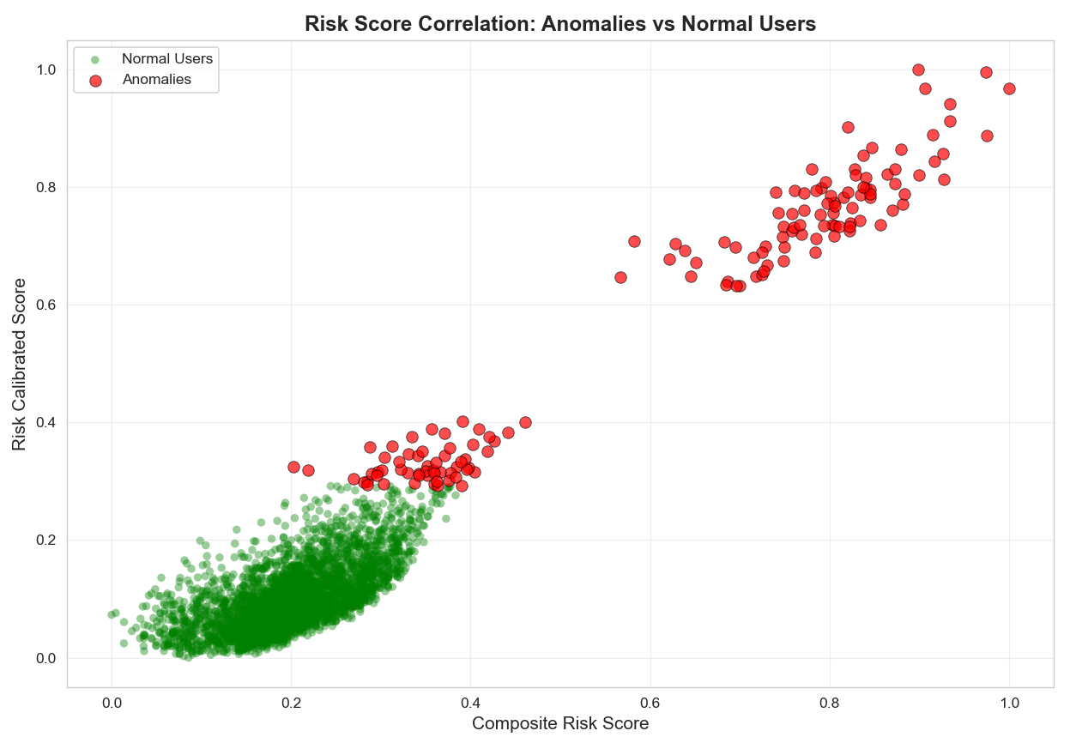
Fig. 8. Anomaly Seperation Plot
Fig. 8 indicates that there is a distinct separation between normal and anomalous users with most normal users gathered in the low-risk category with the anomalies comprising two distinct moderate- and high-risk groups. This systematic segregation proves that Isolation Forest is a systematic way of detecting significant insider-risk trends and not just a deviance, which makes it effective when used to screen threats at an earlier stage.

K-Means Behavioral Clustering Results Interpretation
As shown by the results of the K-Means clustering, four behavioral groups can be distinguished in the organization that can be characterized by specific combinations of activity pattern and psychometrics attributes as illustrated in the radar chart (Fig. 9).

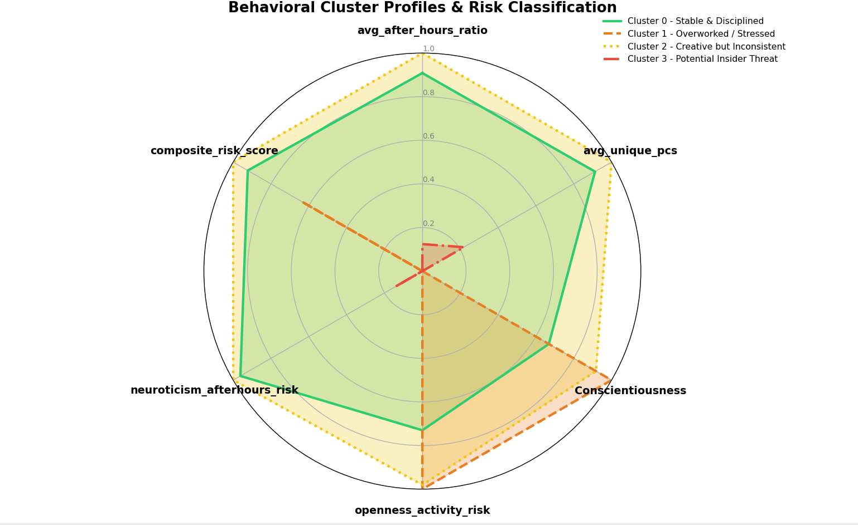
Fig. 9. Radar chart for Behavioral Analysis
These clusters represent:
(i) low-risk and stable and disciplined users (Cluster 0),
(ii) overworked or stressed users with high activity on after-hours (Cluster 1),
(iii) creative users with uneven usage of device (Cluster 2),
(iv) high-risk group, with large composite risk scores (Cluster 3)

Interpretation of Random Forest Classifier Results

Semi-Supervised Label Generation using K-Means
In insider-threat datasets, the ground-truth label of all users is not commonly given and therefore this paper employs a semi-supervised learning approach. K-Means is first applied to group behavioral variables and psychometrics variables in four behavioral groupings of employees (Fig. 10):
- Cluster 0 -Benign / Stable Users
- Cluster 1- Negligent / Overworked Users.
- Cluster 2- Potentially Fraudulent / Suspicious Users
- Cluster 3 - Malicious insiders

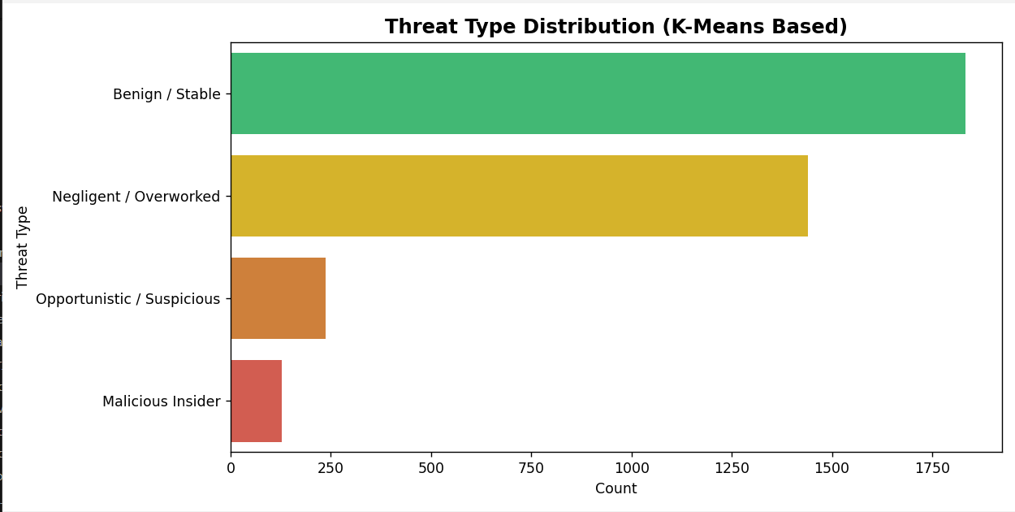
Fig. 10. Thread Type Distribution using K-Means
These groups are converted into pseudo-labels depending on the behavioral patterns that are particular to each of the clusters. Further, these labels are used to train the supervised classifier.

Feature Importance Analysis
The most useful features identified by random forest are (Fig. 11):

- Composite risk score (most dominant)
- Openness activity risk
- after-hours work ratio
- Neuroticism after-hours risk
- Daily activity volume
- Average logon-logoff hours
- Average distinct PCs usage

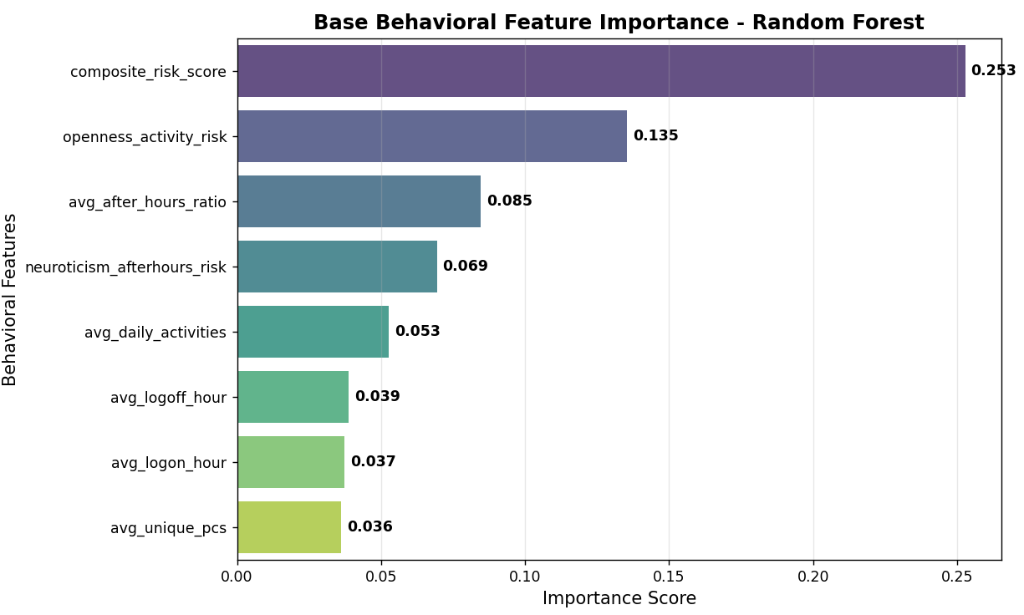
Fig. 11. Bar Plot showing Feature Importance

Confusion Matrix Interpretation

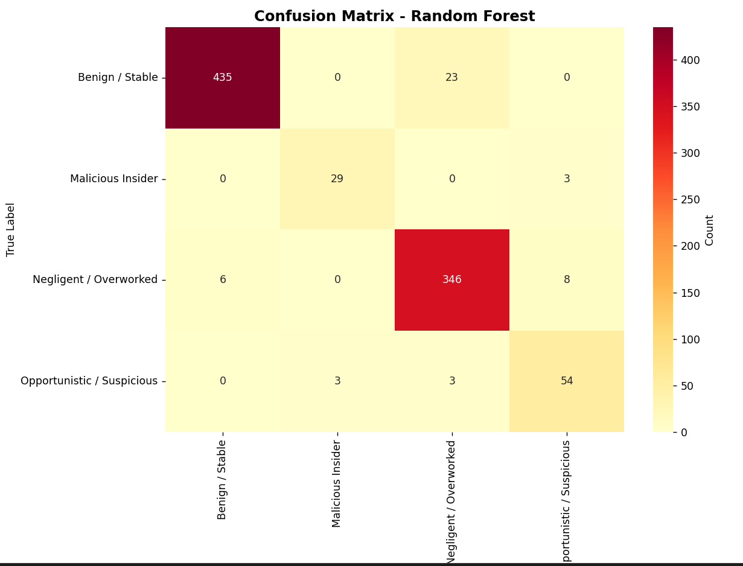
Fig. 12. Confusion Matrix of Random Forest Classifier

The confusion matrix of Fig. 12 indicates that the model perfectly recognizes the Benign and Negligent/Overworked users, whereas Opportunistic/Suspicious users have slight overlap as such users have very similar behaviors. Malicious Insider profiles have been characterized despite the limited samples and this implies that there is a good generalization in all levels of threat.

Random Forest Classification Performance

The almost equal performance values in Table III suggest that the model is very stable, it effectively represents fine behavioral changes and has very low misclassification error between the different threat categories:
Table III. Evaluation Metrics for Random Forest Classifier
Metric | Score
Accuracy | 0.949
Precision | 0.951
Recall | 0.949
F1-Score | 0.950

conclusion
The insider threats are considered as one of the most difficult security risks because of the privileged access of malicious or careless users. The paper showed a hybrid machine learning model that combined anomaly detection, behavioral clustering, and supervised classification to correctly detect and analyze insider risks. Isolation Forest, K-Means, and the Random Forest classifier identified behavioral anomalies, identified distinct behavioral risk patterns, and had over 94 % classification accuracy, precision, recall, and F1-score on the classification of insider threat groups. The results prove that behavior and psychology-aware analytics significantly perform better than traditional rule-based systems and provide understandable risk insights. The future work can build on this framework by balancing real-time streaming data with the temporal behavior modeling approach and explainable AI approaches to optimize early detection and operational utility.

references
- K. Achuthan, S. Ramanathan, S. Srinivas, Raghu Raman, “Advancing cybersecurity and privacy with artificial intelligence: current trends and future research directions, Frontiers in Big Data, Frontiers” , 2024.
- U. Maheswari S, G. Chaudhary, F. Manna, V. P. Khalane, E. Muthukumar, “Cybersecurity Challenges In Fintech: Assessing Threats And Mitigation Strategies For Financial Institutions, Educational Administration: Theory And Practice”, vol. 30, pp.1063-107.
- B. B. Sarhan and N. Altwaijry. "Insider threat detection using machine learning approach" ,Applied Sciences , vol.13, 2022.
- P. V. S. Charan, Gireesh K. T., and P. Anand, “Advance Persistent Threat Detection Using Long Short Term Memory (LSTM) Neural Networks”, Communications in Computer and Information Science, vol. 985, pp. 45-54, 2019.
- R. Nasir, M. Afzal, R. Latif, and W. Iqbal, “Behavioral based insider threat detection using deep learning”, IEEE Access, vol. 9, pp. 143266-143274, 2021.
- M. A. Haq, M. A. R. Khan, and M. Alshehri, “Insider threat detection based on NLP word embedding and machine learning”, Intell, Autom. Soft Comput, vol. 33, pp. 619-635, 2021.
- R. Abhinav, K. N. Raghav, S. S. Reddy, P. S. N. Koushik, S. K. Thangavel and K. Srinivasan, "A Cloud-Based Intrusion Detection System for Advanced Threat Detection and Prevention using Machine Learning Techniques," 2023 14th International Conference on Computing Communication and Networking Technologies (ICCCNT), Delhi, India, pp. 1-8, 2023.
- M. Dosh, “Detecting insider threat within institutions using CERT dataset and different ML techniques”,Periodicals of Engineering and Natural Sciences, vol. 9, pp. 873-884, 2021.
- A. Mittal, and U. Garg, “A proposed approach to analyze insider threat detection using emails”, in 2022 3rd International Conference on Computation, Automation and Knowledge Management (ICCAKM) pp. 1-6, 2022.
- A. Kim, J. Oh, J. Ryu and K. Lee, "A Review of Insider Threat Detection Approaches With IoT Perspective," in IEEE Access, vol. 8, pp. 78847-78867, 2020
- W. Eberle, J. Graves, & L. Holder, “Insider Threat Detection Using a Graph-Based Approach”, Journal of Applied Security Research, vol. 6, pp. 32–81, 2011.

